## Bug #1: Incorrect calculation of fines.

### Script Description

* Test is designed to verify if a patron with a loan one day overdue will incur fines.

### Testing Requirements

This test script covers the following specific testing requirements:

* A loan is one day is overdue.
* When returnbook is called, the program should display that patron has incurred fines.

### Setup

* A loan one day overdue.

### Script Steps

| **Step #** | **Test Action** | **Expected Results** | **Pass/ Fail** |
| --- | --- | --- | --- |
| 1 | Select “return book” | Prompts user to scan book. |  |
| 2 | Enter Book Id | Displays loan details.  Display fine amount.  Prompts answer for if book is damaged | F |

### Test Execution

|  |  |  |  |  |
| --- | --- | --- | --- | --- |
| Date/Time | Tester | Test ID | Test Phase | Status |
| 11/10/20 2:35 pm | Cezanne Alamgir | Bug #1 | System Cycle 1 | Failed |
| 11/10/20 10:37 pm | Cezanne Alamgir | Bug #1 | System Cycle 2 | Passed |

Run 1 – Bug demonstrated

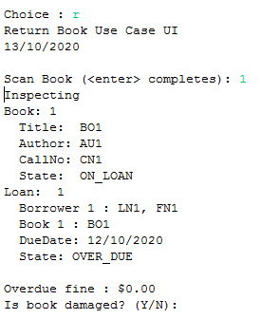

Run 2 – Bug Fixed

